National Textile University,
Faisalabad

Department of Computer Science
Name | Ali Tahir
Class | BSSE 4th
Section | B
Registration No | 24-NTU-CS-1180
Course Name | Introduction to AI
Submitted To | Mam Kainat
Submission Date | February 14, 2026

Lab Task 1:
Screenshots:
Slide 18:
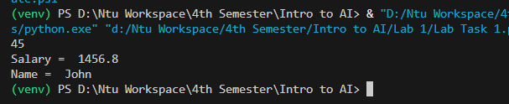
Slide 20:
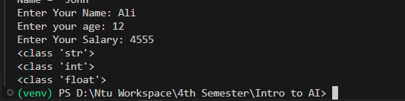
Slide 22:
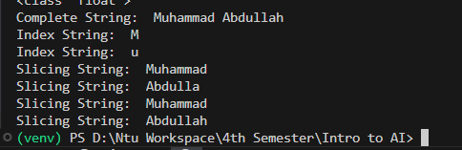
Slide 23:
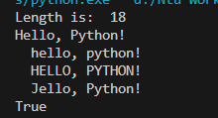

Slide 29:
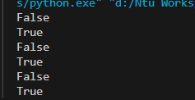
Slide 32:
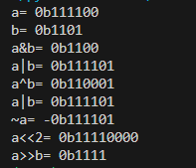
Slide 38:
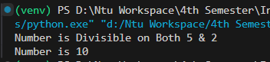
Slide 43:
